**Defined BUSINESS PROCESS:**

A Major airline company provide airline reservation services for its clients through specific channels and tracking the reservation processes, promotions and flights in company for better decision making .

**Declare the grain:**

-Daily activity, Atomic .

**Identifying dimensions:**

Promotion dimension, Upgrade dimension, channel dimension, payment method dimension, care interaction dimension, rewards dimension, flyer dimension, date dimension ,flight dimension .

**Identifying Facts:**

Respond status ,type of payment ,base fair, nights stayed, flyer miles rewarded, flyer miles rewarded explain , payment, type of payment ,care type, problem served ,flyer miles points cost.

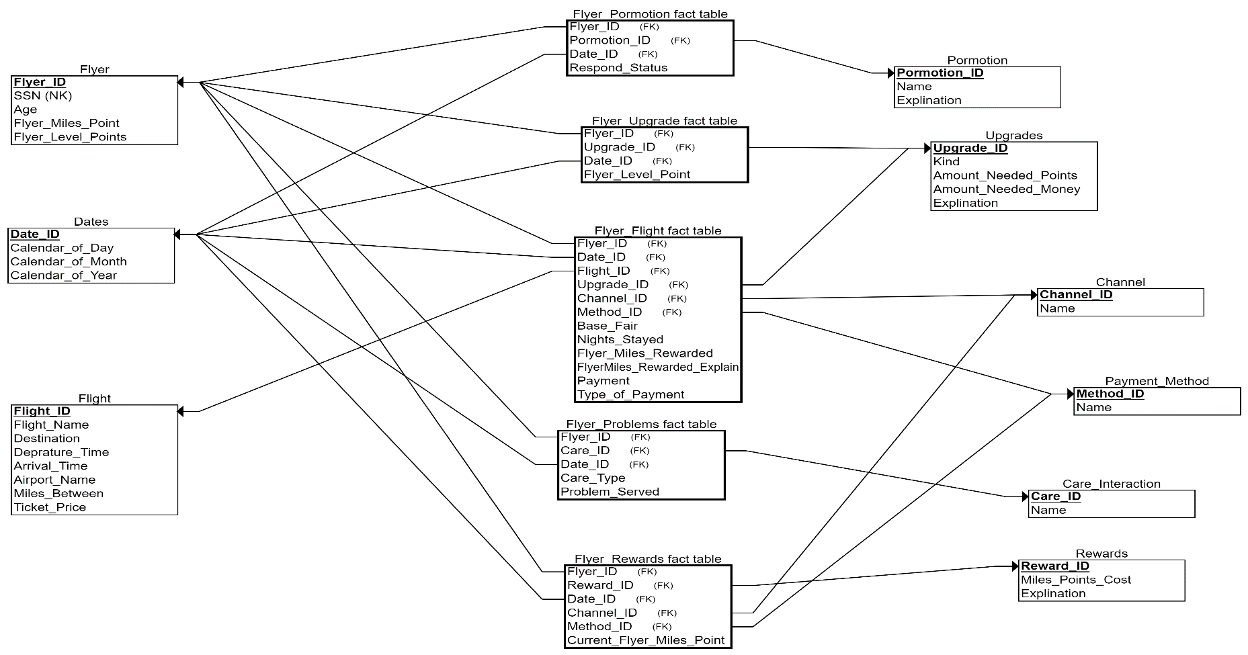

As mentioned in the above dimensional modeling (Galaxy Schema)

-we assumed that we have five fact tables each is related with one or more dimension measures.

-Flyer flight fact table describes when every client reserves a specific flight related with specific channel for payment and specific payment method and with a flight details on specific date , this table measures base fair ,number of nights stayed ,miles rewarded and explanation for these rewards ,payment and type of payment.

-Flyer problem fact table describes customer care interaction before, within and after your trip in order to handle customer inquiries, complaints and keep their feedback it is joined with care interactions, flyer details as dimensions and date details and coming up with solution for problems (problem served).

-Flyer promotion fact table describes promotions offered to specific flight for customers and his respond status with approval or refusal for this promotion.

-Flyer upgrade fact table: this fact table describes for each flyer hold by specific customer and his rank level whether the proportion of these frequent flyers have gold, platinum, aluminum, or titanium status and the type of payment whether miles point or cash payment.

-Reward fact table a fact table describes a set of rewards for customers for their flyer_miles_points_costs which the client can transform into miles points from his flights .